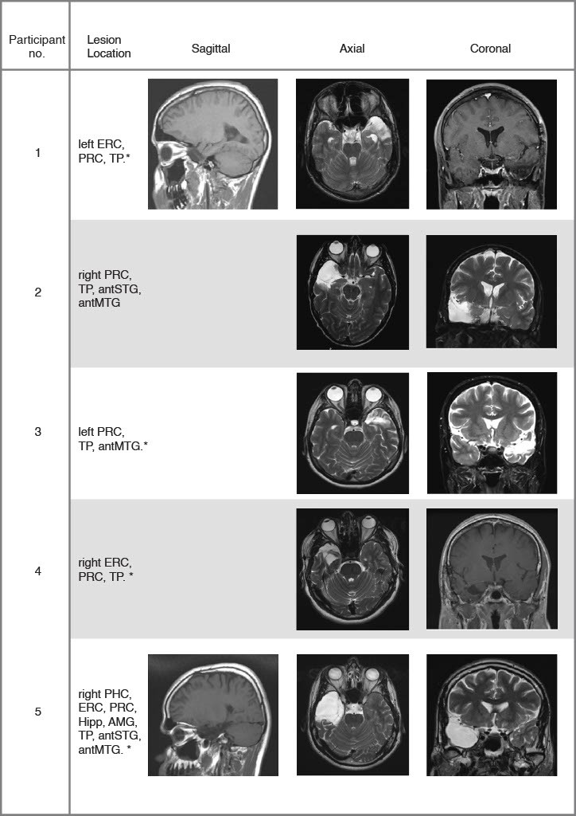

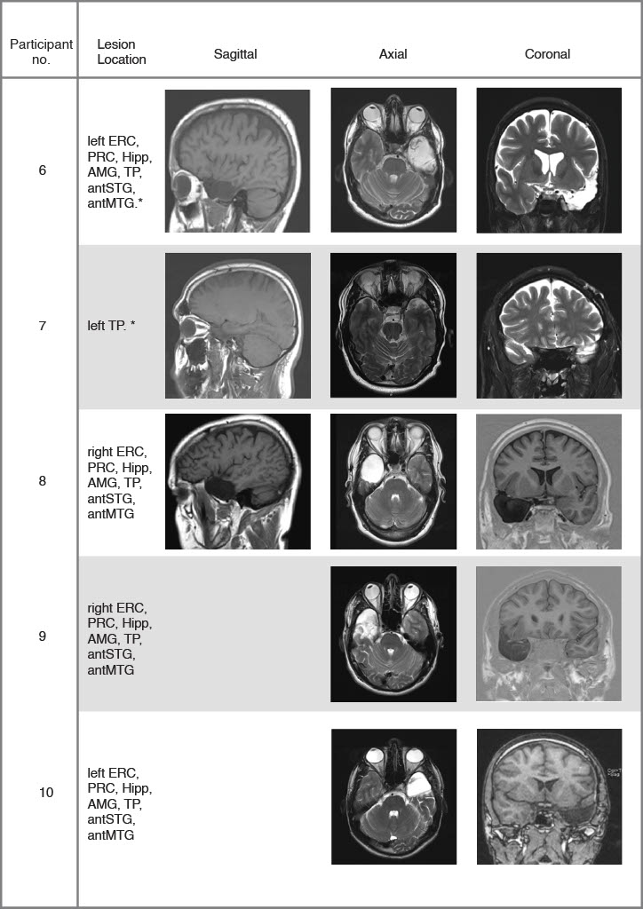

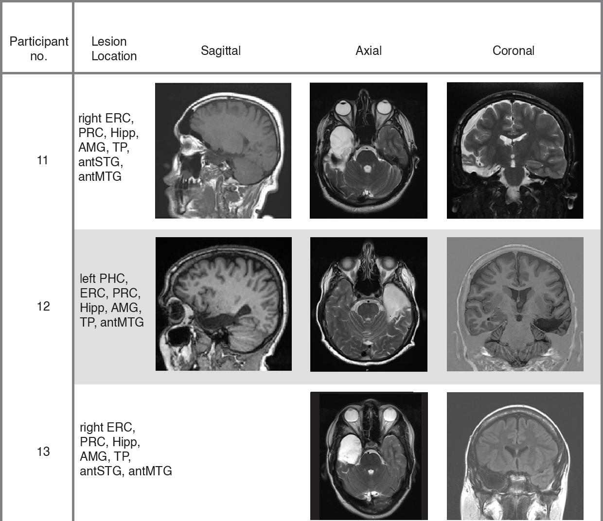

Table 3-1 (Extended data). Post-surgical MRI scans for thirteen patients. The images were obtained with T1 weighted, T2 weighted, Fluid-attenuated Inversion Recovery and Gradient Recalled Echo sequences. Legend: ERC, Entorhinal Cortex; PHC, Parahippocampal Cortex; PRC, Perirhinal Cortex; Hipp, Hippocampus; AMG, Amygdala; Temporal pole, TP; antSTG, anterior Superior Temporal Gyrus; antMTG, anterior Middle Temporal Gyrus.

