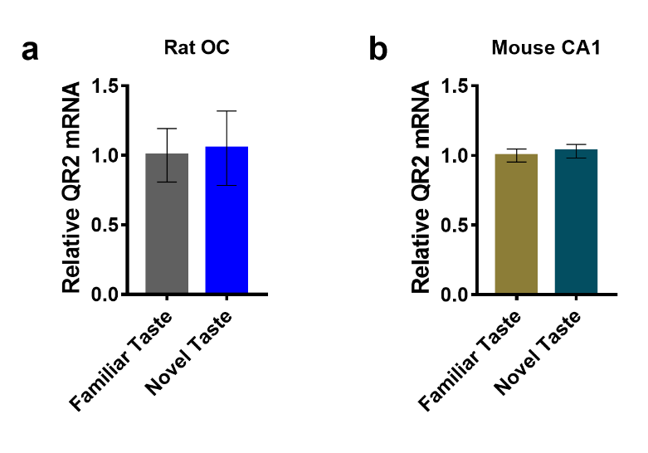
Figure 1-1. QR2 mRNA Expression is Unchanged in Brain Areas Not Associated with Taste Memory Following Novel Taste Consumption.
a) QR2 mRNA is unchanged in rat OC following novel taste consumption. b) QR2 mRNA is unchanged in mouse CA1 following novel taste consumption.

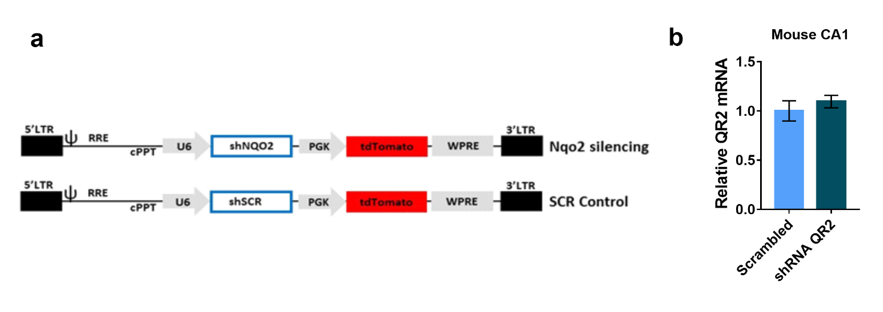
Figure 1-2. Lentivirus Containing Either shRNA Targeting QR2 or a Scrambled Control Injected to aIC Did Not Alter QR2 mRNA Expression in CA1.
a) Diagram of lentivirus containing shRNA targeting QR2, or a scrambled control, used to reduce QR2 expression in mice. b) QR2 expression in CA1 remains unaffected by local aIC infection with lentivirus harboring shRNA targeting QR2.
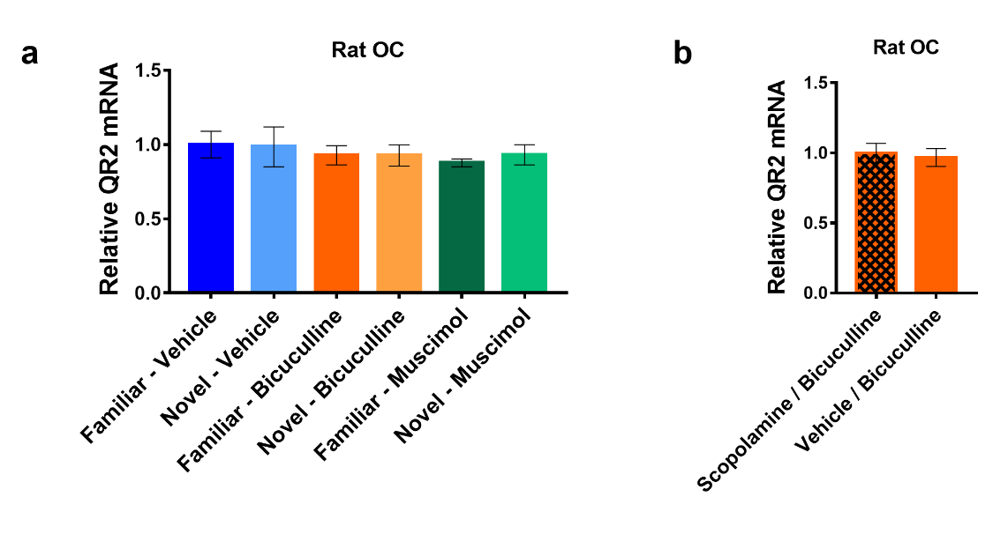
Figure 2-1. Local aIC GABA_{A} Receptor Antagonism and Scopolamine Injections Do Not Affect QR2 mRNA in the Occipital Cortex.
a) QR2 mRNA expression is unchanged following novel taste or antagonism/agonism of GABA_{A}R with bicuculline or muscimol locally in the aIC. b) QR2 expression remains unchanged in the OC of rats, following local antagonism of GABA_{A}R in the aIC, with or without prior injections of scopolamine.
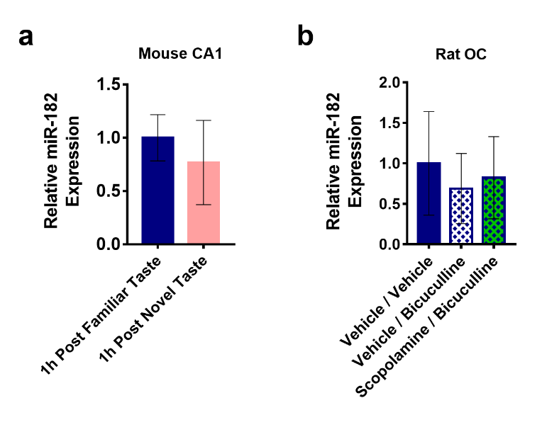
Figure 3-1. miR-182 Expression Does Not Increase in the Mouse CA1 Following Novel Taste Consumption or in the Rat OC Following Pharmacological Manipulation Locally to the Rat aIC.
a) miR-182 levels remain unaltered in the CA1 of mice following novel taste consumption. b) miR-182 levels remain unchanged in the OC of rats, following local aIC antagonism of GABA_{A}R with bicuculline, with or without prior injection of scopolamine.

Figure 3-2. Predicted Hybridization Sites of miR-182 to QR2 mRNA in the Human, Mouse, and Rat Genome.

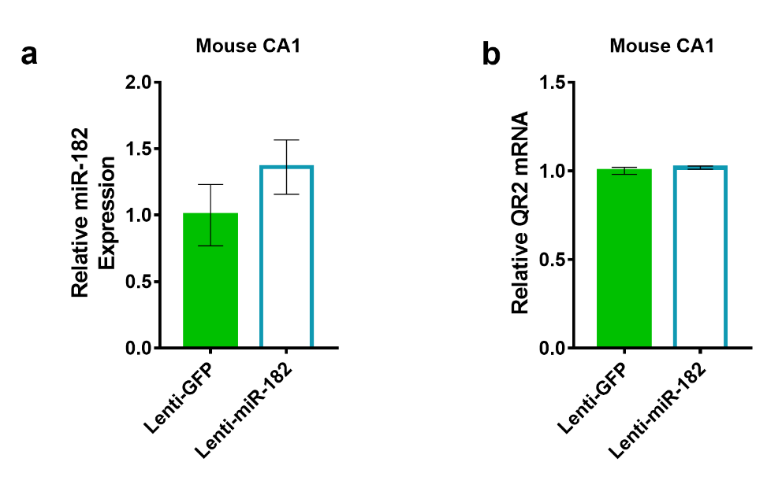
Figure 4-1. Mice Injected to IC with a Lentivirus Expressing miR-182 Do Not Show Changes in QR2 mRNA or miR-182 Expression in the Hippocampus CA1.
a) miR-182 levels in CA1 were not elevated following local aIC infection with a lentivirus overexpressing miR-182. b) QR2 mRNA levels in CA1 were not changed following local aIC infection with a lentivirus overexpressing miR-182.

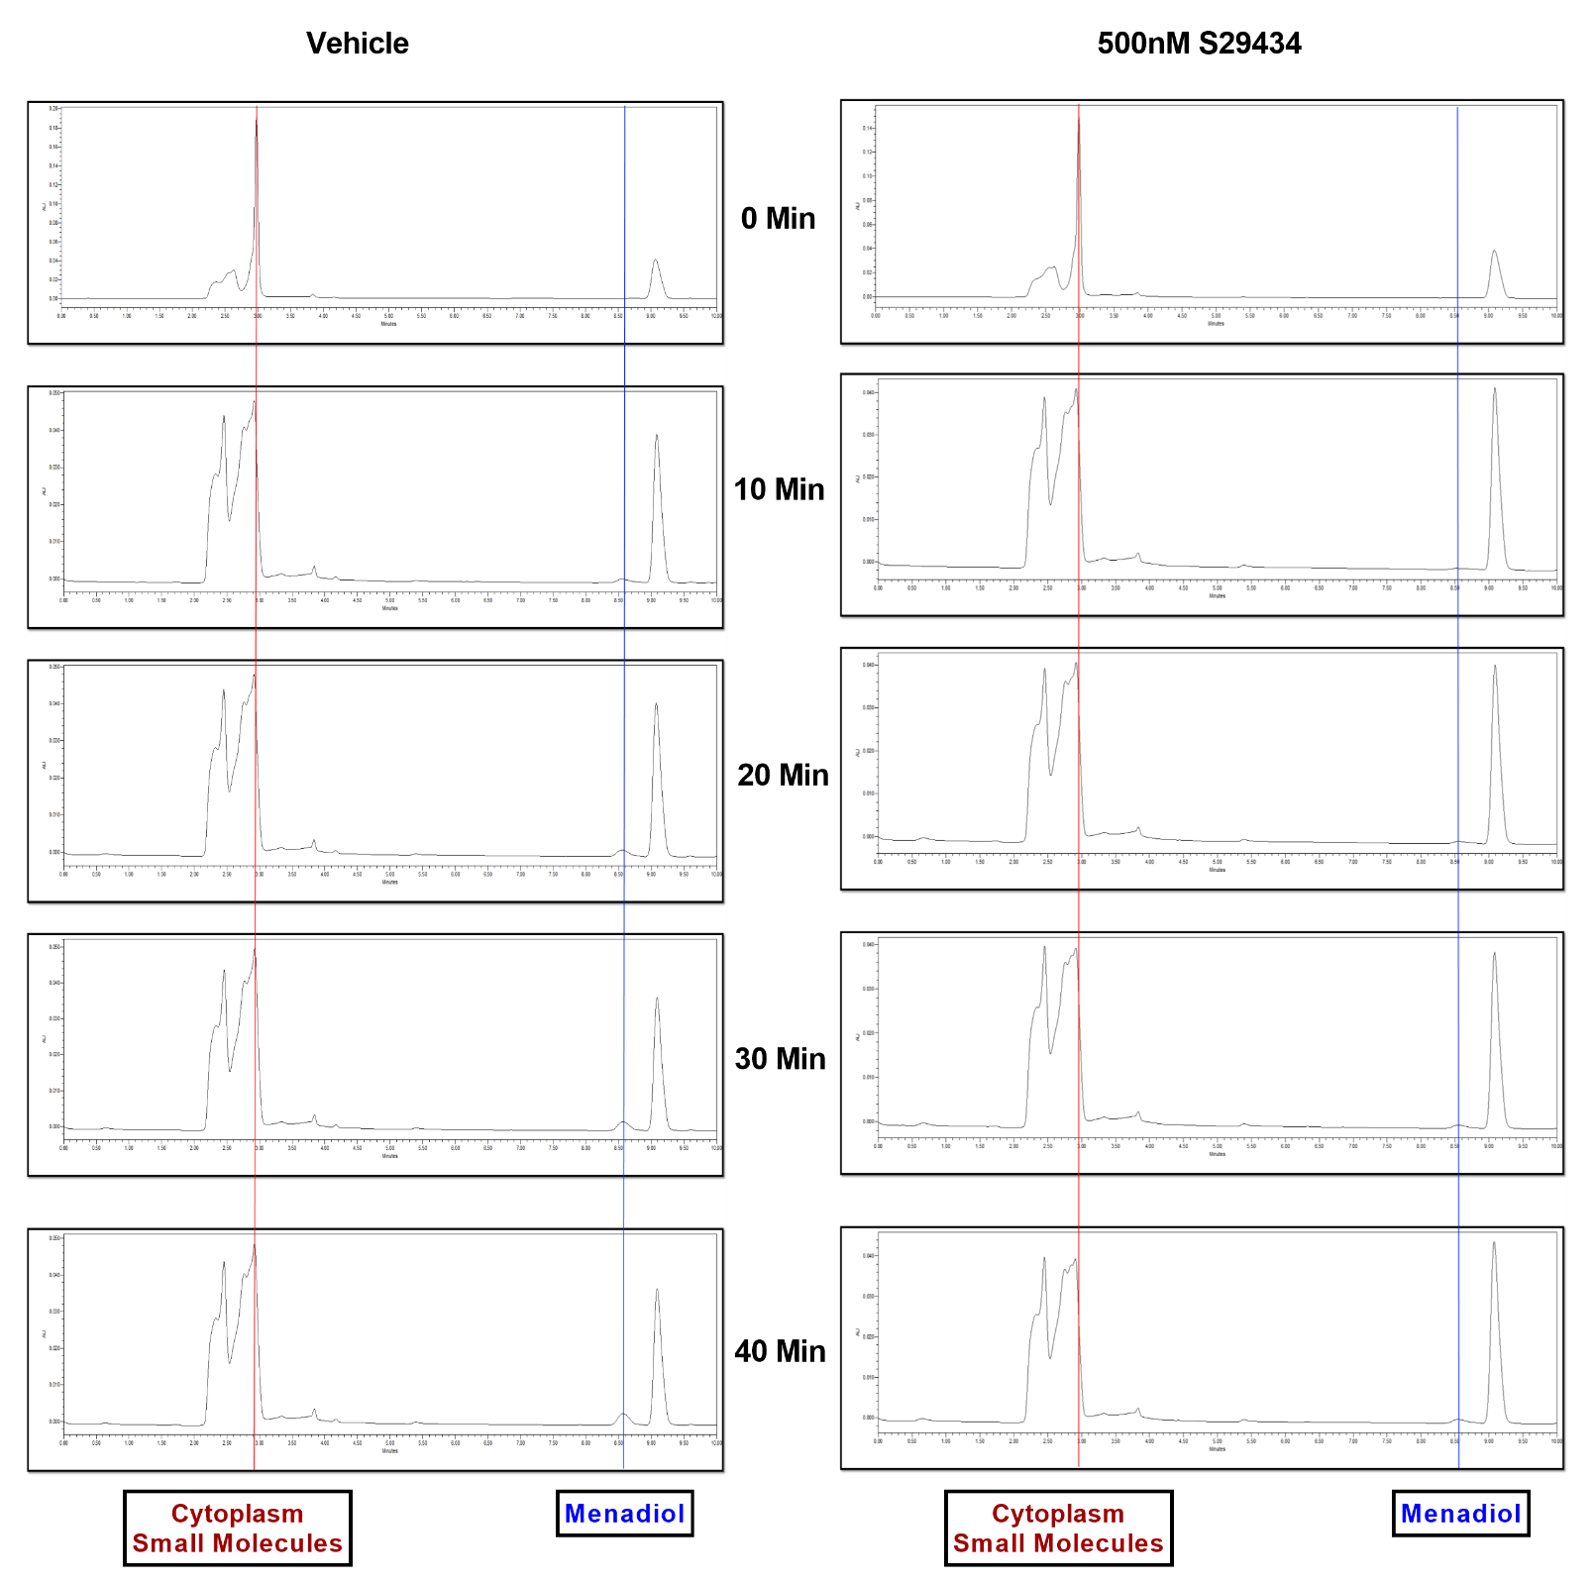 Figure 5-1. Time-Course of Menadiol Formation by QR2 Activity with or without S29434, Using Endogenous Brain Cytoplasmic Small Molecules as Co-Factors.
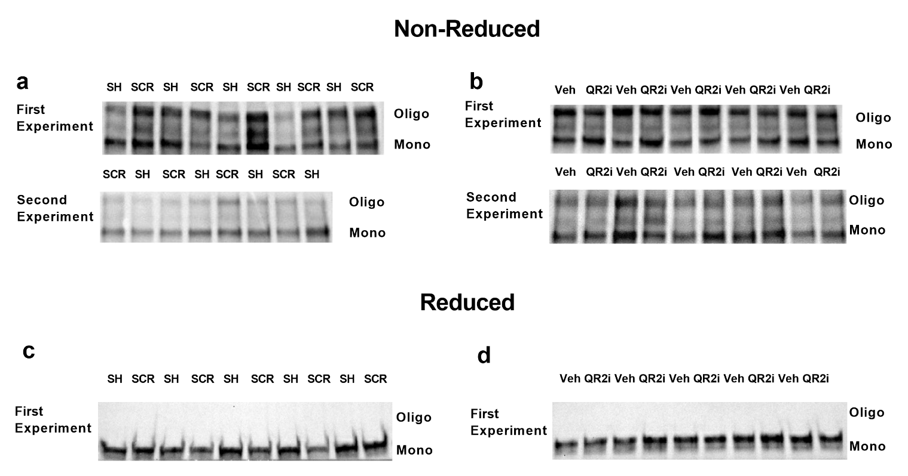
Figure 5-2. Cysteine Redox in Kv2.1 is Sensitive to ROS Generated by QR2 Activity.
a) Kv2.1 blot following non reducing gel electrophoresis of mouse aIC. Top panel and bottom panel represent two separate experiments in which either lentivirus containing shRNA targeting QR2 mRNA or a scrambled control were injected to the mouse aIC. b) Kv2.1 blot following non reducing gel electrophoresis of mouse aIC samples. Top panel and bottom panel represent two separate experiments in which either QR2 inhibitor S29434 or vehicle were injected i.p. c) Kv2.1 oligomerization due to aIC redox state, as seen in a) upper panel, is abolished in the blot following the addition of β mercaptoethanol. d) Kv2.1 oligomerization due to aIC redox state, as seen in b) upper panel, is abolished in the blot following the addition of β mercaptoethanol.
Table 1-1. Detailed Statistical Analysis.
Figure | Statistical analysis | Post hoc tests
Fig. 1b | Familiar 3.21 ± 0.113 ΔCt, n=5; Novel 3.996 ± 0.135 ΔCt, n=4; Student's t test, t=4.497, df=7, p=0.0028
Fig. 1c | Familiar 4.975 ± 0.041 ΔCt, n=7; Novel 5.261 ± 0.095 ΔCt, n=7; Student's t test, t=2.751 df=12, p=0.0176
Fig. 1e | Scrambled 39.22 ± 7.538 %, n=4; shRNA to QR2 84.57 ± 2.381 %, n=5, Student’s t test, t=6.342 df=7, p=0.0004
Fig. 1 f | Scrambled 4.513 ± 0.048 ΔCt, n=4; shRNA QR2 4.784 ± 0.063 ΔCt, n=5; Student's t test, t=3.263, df=7, p=0.0138
Fig. 1i | Vehicle 59.96 ± 7.296%, n=7; S29434 83.45 ± 4.109%, n=7; S29434 Post Acq. 78.45 ± 2.813%, n=7; one way ANOVA, F 1 (2, 18) = 5.886, p=0.0108 | Tukey’s multiple comparison test, Vehicle vs. S29434 p=0.0116, Vehicle vs. S29434 Post Acq. P=0.0489
Fig. 1k | Vehicle/Vehicle 62.67 ± 5.749%, n=11; Scopolamine/Vehicle 37.35 ± 6.476%, n=10; Scopolamine/S29434 65.49 ± 6.029%, n=10; Kruskal-Wallis, p=0.0139 | Dunn’s multiple comparison, Vehicle/Vehicle vs. Scopolamine/Vehicle p=0.0406, Vehicle/Vehicle vs. Scopolamine/S29434 p>0.999, Scopolamine/Vehicle vs Scopolamine/S29434 p=0.0274

Fig. 2b | Vehicle – Novel 6.005 ± 0.259 ΔCt, n=6; Vehicle – Familiar 5.558 ± 0.137 ΔCt, n=4; Bicuculline – Novel 6.082 ± 0.057 ΔCt, n=5; Bicuculline – Familiar 6.125 ± 0.267 ΔCt, n=6; Muscimol – Novel 5.848 ± 0.289 ΔCt, n=5; Muscimol – Familiar 5.837 ± 0.163 ΔCt, n=5; Two way ANOVA, Treatment F=6.343 p=0.006, Taste F=3.026 p=0.094, Interaction F=3.718 p=0.039. | Tukey’s multiple comparison test for treatment, Vehicle vs. Bicuculline p=0.02, Vehicle vs. Muscimol p=0.985, Bicuculline vs Muscimol p=0.029.  ANOVA test of between subject effects, Vehicle – Familiar vs. Vehicle – Novel p=0.014, Bicuculline – Familiar vs. Bicuculline – Novel p=0.735, Muscimol – Familiar vs. Muscimol - Novel p=0.942.
Fig. 2e | Scopolamine/Bicuculline 7.372 ± 0.056 ΔCt, n=8; Vehicle/Bicuculline 7.746 ± 0.119 ΔCt, n=6; Student's t test, t=3.087 df=12, p=0.0094
Fig. 2g | Vehicle 73.28 ± 4.962%, n=8; Bicuculline 87.95 ± 2.849%, n=8; Student's t test, t=2.564 df=14, p=0.0225
Fig. 3a | Familiar 7.377 ± 0.067 ΔCt, n=6; Novel 7.605 ± 0.122 ΔCt, n=6; Student's t test, t=1.637 df=10, p=0.1326
Fig. 3b | Familiar 1 h 12.49 ± 0.248 ΔCt, n=8; Novel 1 h 11.2 ± 0.355 ΔCt, n=8; Mann-Whitney test, p=0.007  Familiar 3 h 13.08 ± 0.446 ΔCt, n=7; Novel 3 h 12.68 ± 0.548 ΔCt, n=7; Student's t test, t=0.5573 df=12, p=0.5876
Fig. 3d | Vehicle/Vehicle 17.06 ± 0.224 ΔCt, n=6; Vehicle/Bicuculline 15.86 ± 0.254 ΔCt, n=6; Scopolamine/Bicuculline 16.63 ± 0.296 ΔCt, n=6; Kruskal-Wallis test, p=0.0147 | Dunn’s multiple comparison test, Vehicle/Vehicle vs. Vehicle/Bicuculline p=0.0206, Vehicle/Vehicle vs. Scopolamine/Bicuculline p>0.999, Vehicle/Bicuculline vs. Scopolamine/Bicuculline p=0.198
Fig. 3f | Vehicle/Vehicle 17.45 ± 0.217 ΔCt, n=5; Vehicle/Eserine 15.99 ± 0.2662 ΔCt, n=5; Student's t test, t=4.241 df=8, p=0.0028
Fig. 4b | GFP 10.79 ± 0.162 ΔCt, n=6; miR-182 5.396 ± 1.522 ΔCt, n=4; Mann-Whitney test, p=0.0095
Fig. 4c | GFP 6.576 ± 0.02059 ΔCt, n=6; miR-182 6.864 ± 0.03825 ΔCt, n=4; Student's t test, t=7.239 df=8, p<0.0001
Fig. 4e | Lenti-GFP 27.17 ± 2.913 %, n=5; Lenti-miR-182 60.63 ± 6.026 %, n=5; Student's t test, t=5 df=8, p=0.0011
Fig. 4f | Lenti-GFP 10.92 ± 0.436 ΔCt, n=5; Lenti-miR-182 8.441 ± 0.341 ΔCt, n=4; Student's t test, t=4.277 df=7, p=0.0037
Fig. 4g | Lenti-GFP 9.145 ± 0.068 ΔCt, n=5; Lenti-miR-182 9.4 ± 0.075 ΔCt, n=4; Student's t test, t=2.509 df=7, p=0.0405
Fig. 5a | QR2 10,643 ± 529.4 AU, n=3; QR2/S29434 569.7 ± 13.97 AU, n=3; Student's t test, t=19.02 df=4, p<0.0001
Fig. 5b | NQO1 11,343 ± 376.7 AU, n=3; NQO1/S29434 11,997 ± 71.39 AU, n=3; NQO1/Dicoumarol 1,409 ± 124.9 AU, n=3; one way ANOVA, F (2, 6) = 619.4, p<0.0001 | Tukey’s multiple comparison test, NQO1 vs. NQO1/S29434 p=0.1958, NQO1 vs. NQO1/Dicoumarol p<0.0001, NQO1/S29434 vs. NQO1/Dicoumarol p<0.0001
Fig. 5c | Brain Lysate 4,834 ± 271.6 AU, n=3; Brain Lysate/S29434 2,967 ± 91.83 AU, n=3; Student's t test, t=7.616 df=4, p=0.0016
Fig. 5d | Two-way repeated measures ANOVA, Dose F (4, 11) = 91.3, p<0.0001; Interaction F (16, 44) = 56.49, p<0.0001; Time F (4, 44) = 1074, p<0.0001; Subjects F (11, 44) = 7.616, p<0.0001; | Tukey's multiple comparison control vs. all treated groups p<0.0001 during 10 – 40 min (complete data in Figure 5d Post Hoc Analysis)
Fig. 5e | Vehicle 8,539 ± 1,057 AU, n=3; Vehicle/BNAH 2,966 ± 218.5 AU, n=3; Dicoumarol/BNAH 15,024 ± 208.2 AU, n=3; S29434/BNAH 2,768 ± 154.4 AU, n=3; one-way ANOVA, p<0.0001 | Tukey’s multiple comparisons test Vehicle vs. Vehicle/BNAH p=0.0005, Vehicle vs. Dicoumarol/BNAH p=0.0001, Vehicle vs. S29434/BNAH p=0.0005, Vehicle/BNAH vs. Dicoumarol/BNAH p<0.0001, Vehicle/BNAH vs. S29434/BNAH p>0.9999, Dicoumarol/BNAH vs. S29434/BNAH p<0.0001
Fig. 5f | Vehicle 8,539 ± 1,057 AU, n=3; S29434 (0.2µM) 10,709 ± 662.8 AU, n=3; S29434 (2µM) 8,090 ± 440.1 AU, n=3; S29434 (20µM) 4,644 ± 344.2 AU, n=3; one way ANOVA, p=0.0036 | Tukey’s multiple comparisons test Vehicle vs. S29434 (0.2µM) p=0.1909, Vehicle vs. S29434 (2µM) p=0.9647, Vehicle vs. S29434 (20µM) p=0.0390, S29434 (0.2µM) vs. S29434 (2µM) p=0.1002, S29434 (0.2µM) vs. S29434 (20µM) p=0.0022, S29434(2µM) vs. S29434 (20µM) p=0.0750
Fig. 5g | Lenti-Scrambled 1 ± 0.04766 AU, n=9; Lenti-shRNA QR2 0.7881 ± 0.05523 AU, n=9; Mann-Whitney test, p=0.0106
Fig. 5h | Vehicle 1 ± 0.03299 AU, n=10; S29434 0.8947 ± 0.03452 AU, n=10; Mann-Whitney test, p= 0.0524
Extended Data Fig. 1a | Familiar 1.757 ± 0.2225 ΔCt, n=4; Novel 1.685 ± 0.308 ΔCt, n=4; Student's t test, t=0.1886 df=6, p=0.8566
Extended Data Fig. 1b | Familiar 4.286 ± 0.05 ΔCt, n=7; Novel 4.242 ± 0.053 ΔCt, n=7; Student's t test, t=0.6052 df=12, p=0.5563
Extended Data Fig. 2b | Scrambled 5.024 ± 0.118 ΔCt, n=4; shRNA QR2 4.893 ± 0.072 ΔCt, n=5; Student's t test, t=0.9903 df=7, p=0.355
Extended Data Fig. 3a | Familiar-Vehicle 8.103 ± 0.1035 ΔCt, n=4; Novel-Vehicle 8.126 ± 0.147 ΔCt, n=6; Familiar-Bicuculline 8.212 ± 0.07281 ΔCt, n=5; Novel-Bicuculline 8.214 ± 0.07981 ΔCt, n=5; Familiar-Muscimol 8.293 ± 0.03054 ΔCt, n=4; Novel-Muscimol 8.207 ± 0.07616 ΔCt, n=5; Two way ANOVA, Taste F=0.060 p=0.809, Treatment F=0.934 p=0.407, Interaction F=0.155 p=0.857
Extended Data Fig. 3b | Scopolamine/Bicuculline 8.118 ± 0.0731 ΔCt, n=8; Veh/Bic 8.166 ± 0.07022 ΔCt, n=6; Mann-Whitney test, p=0.8518
Extended Data Fig. 4a | 1 h Post Familiar Taste Hippocampus 16.65 ± 0.2314 ΔCt, n=8; 1 h Post Novel Taste Hippocampus 17.03 ± 0.422 ΔCt, n=8; Student t test, t=0.7885 df=14, p=0.4435
Extended Data Fig. 4b | Vehicle / Vehicle 13.14 ± 0.715 ΔCt, n=5; Vehicle / Bicuculline 13.68 ± 0.474 ΔCt, n=6; Scopolamine / Bicuculline 13.42 ± 0.554 ΔCt, n=6; Kruskal-Wallis test, p=0.8791 | Dunn’s multiple comparison test, Vehicle / Vehicle vs. Vehicle / Bicuculline p>0.9999, Vehicle / Vehicle vs. Scopolamine / Bicuculline p>0.9999, Vehicle / Bicuculline vs. Scopolamine / Bicuculline p>0.9999
Extended Data Fig. 5a | Lenti-GFP Hippocampus 15.72 ± 0.2585 ΔCt, n=5; Lenti-miR-182 Hippocampus 15.27 ± 0.235 ΔCt, n=4; Student t test, t=1.239 df=7, p=0.2554
Extended Data Fig. 5b | Lenti-GFP Hippocampus 8.814 ± 0.022 ΔCt, n=5; Lenti-miR-182 Hippocampus 8.788 ± 0.010 ΔCt, n=4; Student t test, t=0.986 df=7, p=0.3568

Figure 5d Post Hoc Analysis.
Tukey's multiple comparisons test | Mean Diff. | 95.00% CI of diff. | Significant? | Summary | Adjusted P Value
0 min
Control vs. 62.5nM S29434 | 1446 | -6013 to 8905 | No | ns | 0.9819
Control vs. 125nM S29434 | 1374 | -6084 to 8833 | No | ns | 0.9850
Control vs. 250nM S29434 | 1362 | -6097 to 8821 | No | ns | 0.9855
Control vs. 500nM S29434 | 1318 | -5659 to 8295 | No | ns | 0.9836
62.5nM S29434 vs. 125nM S29434 | -71.67 | -7530 to 7387 | No | ns | >0.9999
62.5nM S29434 vs. 250nM S29434 | -84 | -7543 to 7375 | No | ns | >0.9999
62.5nM S29434 vs. 500nM S29434 | -128.3 | -7105 to 6849 | No | ns | >0.9999
125nM S29434 vs. 250nM S29434 | -12.33 | -7471 to 7446 | No | ns | >0.9999
125nM S29434 vs. 500nM S29434 | -56.67 | -7034 to 6920 | No | ns | >0.9999
250nM S29434 vs. 500nM S29434 | -44.33 | -7021 to 6933 | No | ns | >0.9999
10 min
Control vs. 62.5nM S29434 | 19949 | 12490 to 27408 | Yes | **** | <0.0001
Control vs. 125nM S29434 | 22421 | 14962 to 29880 | Yes | **** | <0.0001
Control vs. 250nM S29434 | 25220 | 17761 to 32679 | Yes | **** | <0.0001
Control vs. 500nM S29434 | 31852 | 24875 to 38829 | Yes | **** | <0.0001
62.5nM S29434 vs. 125nM S29434 | 2472 | -4987 to 9931 | No | ns | 0.8821
62.5nM S29434 vs. 250nM S29434 | 5271 | -2188 to 12730 | No | ns | 0.2829
62.5nM S29434 vs. 500nM S29434 | 11903 | 4926 to 18880 | Yes | *** | 0.0001
125nM S29434 vs. 250nM S29434 | 2799 | -4660 to 10258 | No | ns | 0.8267
125nM S29434 vs. 500nM S29434 | 9431 | 2454 to 16408 | Yes | ** | 0.0031
250nM S29434 vs. 500nM S29434 | 6632 | -345 to 13609 | No | ns | 0.0699
20 min
Control vs. 62.5nM S29434 | 23239 | 15781 to 30698 | Yes | **** | <0.0001
Control vs. 125nM S29434 | 28041 | 20582 to 35500 | Yes | **** | <0.0001
Control vs. 250nM S29434 | 30954 | 23496 to 38413 | Yes | **** | <0.0001
Control vs. 500nM S29434 | 46702 | 39725 to 53679 | Yes | **** | <0.0001
62.5nM S29434 vs. 125nM S29434 | 4802 | -2657 to 12260 | No | ns | 0.3752
62.5nM S29434 vs. 250nM S29434 | 7715 | 256.4 to 15174 | Yes | * | 0.0392
62.5nM S29434 vs. 500nM S29434 | 23463 | 16486 to 30440 | Yes | **** | <0.0001
125nM S29434 vs. 250nM S29434 | 2913 | -4545 to 10372 | No | ns | 0.8049
125nM S29434 vs. 500nM S29434 | 18661 | 11684 to 25638 | Yes | **** | <0.0001
250nM S29434 vs. 500nM S29434 | 15748 | 8771 to 22725 | Yes | **** | <0.0001
30 min
Control vs. 62.5nM S29434 | 18079 | 10621 to 25538 | Yes | **** | <0.0001
Control vs. 125nM S29434 | 24152 | 16694 to 31611 | Yes | **** | <0.0001
Control vs. 250nM S29434 | 28094 | 20635 to 35552 | Yes | **** | <0.0001
Control vs. 500nM S29434 | 51729 | 44753 to 58706 | Yes | **** | <0.0001
62.5nM S29434 vs. 125nM S29434 | 6073 | -1386 to 13532 | No | ns | 0.1616
62.5nM S29434 vs. 250nM S29434 | 10014 | 2556 to 17473 | Yes | ** | 0.0034
62.5nM S29434 vs. 500nM S29434 | 33650 | 26673 to 40627 | Yes | **** | <0.0001
125nM S29434 vs. 250nM S29434 | 3941 | -3517 to 11400 | No | ns | 0.5730
125nM S29434 vs. 500nM S29434 | 27577 | 20600 to 34554 | Yes | **** | <0.0001
250nM S29434 vs. 500nM S29434 | 23636 | 16659 to 30613 | Yes | **** | <0.0001
40 min
Control vs. 62.5nM S29434 | 16579 | 9120 to 24037 | Yes | **** | <0.0001
Control vs. 125nM S29434 | 22147 | 14689 to 29606 | Yes | **** | <0.0001
Control vs. 250nM S29434 | 26967 | 19508 to 34426 | Yes | **** | <0.0001
Control vs. 500nM S29434 | 56510 | 49533 to 63487 | Yes | **** | <0.0001
62.5nM S29434 vs. 125nM S29434 | 5569 | -1890 to 13027 | No | ns | 0.2324
62.5nM S29434 vs. 250nM S29434 | 10388 | 2930 to 17847 | Yes | ** | 0.0022
62.5nM S29434 vs. 500nM S29434 | 39932 | 32955 to 46908 | Yes | **** | <0.0001
125nM S29434 vs. 250nM S29434 | 4820 | -2639 to 12278 | No | ns | 0.3714
125nM S29434 vs. 500nM S29434 | 34363 | 27386 to 41340 | Yes | **** | <0.0001
250nM S29434 vs. 500nM S29434 | 29543 | 22566 to 36520 | Yes | **** | <0.0001
Test details | Mean 1 | Mean 2 | Mean Diff. | SE of diff. | N1 | N2 | q | DF
0 min
Control vs. 62.5nM S29434 | 2179 | 732.7 | 1446 | 2645 | 3 | 3 | 0.7733 | 55
Control vs. 125nM S29434 | 2179 | 804.3 | 1374 | 2645 | 3 | 3 | 0.7349 | 55
Control vs. 250nM S29434 | 2179 | 816.7 | 1362 | 2645 | 3 | 3 | 0.7283 | 55
Control vs. 500nM S29434 | 2179 | 861 | 1318 | 2474 | 3 | 4 | 0.7533 | 55
62.5nM S29434 vs. 125nM S29434 | 732.7 | 804.3 | -71.67 | 2645 | 3 | 3 | 0.03832 | 55
62.5nM S29434 vs. 250nM S29434 | 732.7 | 816.7 | -84 | 2645 | 3 | 3 | 0.04492 | 55
62.5nM S29434 vs. 500nM S29434 | 732.7 | 861 | -128.3 | 2474 | 3 | 4 | 0.07337 | 55
125nM S29434 vs. 250nM S29434 | 804.3 | 816.7 | -12.33 | 2645 | 3 | 3 | 0.006595 | 55
125nM S29434 vs. 500nM S29434 | 804.3 | 861 | -56.67 | 2474 | 3 | 4 | 0.0324 | 55
250nM S29434 vs. 500nM S29434 | 816.7 | 861 | -44.33 | 2474 | 3 | 4 | 0.02534 | 55
10 min
Control vs. 62.5nM S29434 | 35972 | 16023 | 19949 | 2645 | 3 | 3 | 10.67 | 55
Control vs. 125nM S29434 | 35972 | 13551 | 22421 | 2645 | 3 | 3 | 11.99 | 55
Control vs. 250nM S29434 | 35972 | 10752 | 25220 | 2645 | 3 | 3 | 13.49 | 55
Control vs. 500nM S29434 | 35972 | 4121 | 31852 | 2474 | 3 | 4 | 18.21 | 55
62.5nM S29434 vs. 125nM S29434 | 16023 | 13551 | 2472 | 2645 | 3 | 3 | 1.322 | 55
62.5nM S29434 vs. 250nM S29434 | 16023 | 10752 | 5271 | 2645 | 3 | 3 | 2.819 | 55
62.5nM S29434 vs. 500nM S29434 | 16023 | 4121 | 11903 | 2474 | 3 | 4 | 6.805 | 55
125nM S29434 vs. 250nM S29434 | 13551 | 10752 | 2799 | 2645 | 3 | 3 | 1.497 | 55
125nM S29434 vs. 500nM S29434 | 13551 | 4121 | 9431 | 2474 | 3 | 4 | 5.391 | 55
250nM S29434 vs. 500nM S29434 | 10752 | 4121 | 6632 | 2474 | 3 | 4 | 3.791 | 55
20 min
Control vs. 62.5nM S29434 | 52825 | 29586 | 23239 | 2645 | 3 | 3 | 12.43 | 55
Control vs. 125nM S29434 | 52825 | 24784 | 28041 | 2645 | 3 | 3 | 15 | 55
Control vs. 250nM S29434 | 52825 | 21871 | 30954 | 2645 | 3 | 3 | 16.55 | 55
Control vs. 500nM S29434 | 52825 | 6123 | 46702 | 2474 | 3 | 4 | 26.7 | 55
62.5nM S29434 vs. 125nM S29434 | 29586 | 24784 | 4802 | 2645 | 3 | 3 | 2.568 | 55
62.5nM S29434 vs. 250nM S29434 | 29586 | 21871 | 7715 | 2645 | 3 | 3 | 4.126 | 55
62.5nM S29434 vs. 500nM S29434 | 29586 | 6123 | 23463 | 2474 | 3 | 4 | 13.41 | 55
125nM S29434 vs. 250nM S29434 | 24784 | 21871 | 2913 | 2645 | 3 | 3 | 1.558 | 55
125nM S29434 vs. 500nM S29434 | 24784 | 6123 | 18661 | 2474 | 3 | 4 | 10.67 | 55
250nM S29434 vs. 500nM S29434 | 21871 | 6123 | 15748 | 2474 | 3 | 4 | 9.003 | 55
30 min
Control vs. 62.5nM S29434 | 61535 | 43455 | 18079 | 2645 | 3 | 3 | 9.668 | 55
Control vs. 125nM S29434 | 61535 | 37382 | 24152 | 2645 | 3 | 3 | 12.92 | 55
Control vs. 250nM S29434 | 61535 | 33441 | 28094 | 2645 | 3 | 3 | 15.02 | 55
Control vs. 500nM S29434 | 61535 | 9805 | 51729 | 2474 | 3 | 4 | 29.57 | 55
62.5nM S29434 vs. 125nM S29434 | 43455 | 37382 | 6073 | 2645 | 3 | 3 | 3.248 | 55
62.5nM S29434 vs. 250nM S29434 | 43455 | 33441 | 10014 | 2645 | 3 | 3 | 5.355 | 55
62.5nM S29434 vs. 500nM S29434 | 43455 | 9805 | 33650 | 2474 | 3 | 4 | 19.24 | 55
125nM S29434 vs. 250nM S29434 | 37382 | 33441 | 3941 | 2645 | 3 | 3 | 2.108 | 55
125nM S29434 vs. 500nM S29434 | 37382 | 9805 | 27577 | 2474 | 3 | 4 | 15.77 | 55
250nM S29434 vs. 500nM S29434 | 33441 | 9805 | 23636 | 2474 | 3 | 4 | 13.51 | 55
40 min
Control vs. 62.5nM S29434 | 70084 | 53505 | 16579 | 2645 | 3 | 3 | 8.866 | 55
Control vs. 125nM S29434 | 70084 | 47936 | 22147 | 2645 | 3 | 3 | 11.84 | 55
Control vs. 250nM S29434 | 70084 | 43117 | 26967 | 2645 | 3 | 3 | 14.42 | 55
Control vs. 500nM S29434 | 70084 | 13574 | 56510 | 2474 | 3 | 4 | 32.31 | 55
62.5nM S29434 vs. 125nM S29434 | 53505 | 47936 | 5569 | 2645 | 3 | 3 | 2.978 | 55
62.5nM S29434 vs. 250nM S29434 | 53505 | 43117 | 10388 | 2645 | 3 | 3 | 5.555 | 55
62.5nM S29434 vs. 500nM S29434 | 53505 | 13574 | 39932 | 2474 | 3 | 4 | 22.83 | 55
125nM S29434 vs. 250nM S29434 | 47936 | 43117 | 4820 | 2645 | 3 | 3 | 2.577 | 55
125nM S29434 vs. 500nM S29434 | 47936 | 13574 | 34363 | 2474 | 3 | 4 | 19.64 | 55
250nM S29434 vs. 500nM S29434 | 43117 | 13574 | 29543 | 2474 | 3 | 4 | 16.89 | 55

Tukey's multiple comparisons test | Mean Diff. | 95.00% CI of diff. | Significant? | Summary | Adjusted P Value
Control
0 min vs. 10 min | -33794 | -38728 to -28859 | Yes | **** | <0.0001
0 min vs. 20 min | -50647 | -55581 to -45712 | Yes | **** | <0.0001
0 min vs. 30 min | -59356 | -64291 to -54421 | Yes | **** | <0.0001
0 min vs. 40 min | -67905 | -72840 to -62970 | Yes | **** | <0.0001
10 min vs. 20 min | -16853 | -21788 to -11918 | Yes | **** | <0.0001
10 min vs. 30 min | -25562 | -30497 to -20628 | Yes | **** | <0.0001
10 min vs. 40 min | -34111 | -39046 to -29177 | Yes | **** | <0.0001
20 min vs. 30 min | -8709 | -13644 to -3775 | Yes | **** | <0.0001
20 min vs. 40 min | -17258 | -22193 to -12324 | Yes | **** | <0.0001
30 min vs. 40 min | -8549 | -13484 to -3614 | Yes | *** | 0.0001
62.5nM S29434
0 min vs. 10 min | -15291 | -20225 to -10356 | Yes | **** | <0.0001
0 min vs. 20 min | -28853 | -33788 to -23919 | Yes | **** | <0.0001
0 min vs. 30 min | -42723 | -47657 to -37788 | Yes | **** | <0.0001
0 min vs. 40 min | -52772 | -57707 to -47838 | Yes | **** | <0.0001
10 min vs. 20 min | -13563 | -18497 to -8628 | Yes | **** | <0.0001
10 min vs. 30 min | -27432 | -32367 to -22497 | Yes | **** | <0.0001
10 min vs. 40 min | -37482 | -42416 to -32547 | Yes | **** | <0.0001
20 min vs. 30 min | -13869 | -18804 to -8935 | Yes | **** | <0.0001
20 min vs. 40 min | -23919 | -28854 to -18984 | Yes | **** | <0.0001
30 min vs. 40 min | -10050 | -14984 to -5115 | Yes | **** | <0.0001
125nM S29434
0 min vs. 10 min | -12747 | -17682 to -7812 | Yes | **** | <0.0001
0 min vs. 20 min | -23980 | -28915 to -19045 | Yes | **** | <0.0001
0 min vs. 30 min | -36578 | -41513 to -31643 | Yes | **** | <0.0001
0 min vs. 40 min | -47132 | -52067 to -42197 | Yes | **** | <0.0001
10 min vs. 20 min | -11233 | -16168 to -6298 | Yes | **** | <0.0001
10 min vs. 30 min | -23831 | -28766 to -18896 | Yes | **** | <0.0001
10 min vs. 40 min | -34385 | -39320 to -29450 | Yes | **** | <0.0001
20 min vs. 30 min | -12598 | -17533 to -7663 | Yes | **** | <0.0001
20 min vs. 40 min | -23152 | -28087 to -18217 | Yes | **** | <0.0001
30 min vs. 40 min | -10554 | -15489 to -5619 | Yes | **** | <0.0001
250nM S29434
0 min vs. 10 min | -9936 | -14870 to -5001 | Yes | **** | <0.0001
0 min vs. 20 min | -21054 | -25989 to -16120 | Yes | **** | <0.0001
0 min vs. 30 min | -32624 | -37559 to -27690 | Yes | **** | <0.0001
0 min vs. 40 min | -42300 | -47235 to -37365 | Yes | **** | <0.0001
10 min vs. 20 min | -11119 | -16053 to -6184 | Yes | **** | <0.0001
10 min vs. 30 min | -22689 | -27623 to -17754 | Yes | **** | <0.0001
10 min vs. 40 min | -32364 | -37299 to -27430 | Yes | **** | <0.0001
20 min vs. 30 min | -11570 | -16505 to -6635 | Yes | **** | <0.0001
20 min vs. 40 min | -21246 | -26180 to -16311 | Yes | **** | <0.0001
30 min vs. 40 min | -9676 | -14610 to -4741 | Yes | **** | <0.0001
500nM S29434
0 min vs. 10 min | -3260 | -7533 to 1014 | No | ns | 0.2104
0 min vs. 20 min | -5262 | -9536 to -988.7 | Yes | ** | 0.0090
0 min vs. 30 min | -8944 | -13218 to -4671 | Yes | **** | <0.0001
0 min vs. 40 min | -12713 | -16986 to -8439 | Yes | **** | <0.0001
10 min vs. 20 min | -2003 | -6276 to 2271 | No | ns | 0.6726
10 min vs. 30 min | -5685 | -9958 to -1411 | Yes | ** | 0.0040
10 min vs. 40 min | -9453 | -13727 to -5179 | Yes | **** | <0.0001
20 min vs. 30 min | -3682 | -7956 to 591.5 | No | ns | 0.1211
20 min vs. 40 min | -7450 | -11724 to -3177 | Yes | *** | 0.0001
30 min vs. 40 min | -3768 | -8042 to 505.3 | No | ns | 0.1073
Test details | Mean 1 | Mean 2 | Mean Diff. | SE of diff. | N1 | N2 | q | DF
Control
0 min vs. 10 min | 2179 | 35972 | -33794 | 1735 | 3 | 3 | 27.54 | 44
0 min vs. 20 min | 2179 | 52825 | -50647 | 1735 | 3 | 3 | 41.28 | 44
0 min vs. 30 min | 2179 | 61535 | -59356 | 1735 | 3 | 3 | 48.38 | 44
0 min vs. 40 min | 2179 | 70084 | -67905 | 1735 | 3 | 3 | 55.35 | 44
10 min vs. 20 min | 35972 | 52825 | -16853 | 1735 | 3 | 3 | 13.74 | 44
10 min vs. 30 min | 35972 | 61535 | -25562 | 1735 | 3 | 3 | 20.84 | 44
10 min vs. 40 min | 35972 | 70084 | -34111 | 1735 | 3 | 3 | 27.8 | 44
20 min vs. 30 min | 52825 | 61535 | -8709 | 1735 | 3 | 3 | 7.099 | 44
20 min vs. 40 min | 52825 | 70084 | -17258 | 1735 | 3 | 3 | 14.07 | 44
30 min vs. 40 min | 61535 | 70084 | -8549 | 1735 | 3 | 3 | 6.968 | 44
62.5nM S29434
0 min vs. 10 min | 732.7 | 16023 | -15291 | 1735 | 3 | 3 | 12.46 | 44
0 min vs. 20 min | 732.7 | 29586 | -28853 | 1735 | 3 | 3 | 23.52 | 44
0 min vs. 30 min | 732.7 | 43455 | -42723 | 1735 | 3 | 3 | 34.82 | 44
0 min vs. 40 min | 732.7 | 53505 | -52772 | 1735 | 3 | 3 | 43.01 | 44
10 min vs. 20 min | 16023 | 29586 | -13563 | 1735 | 3 | 3 | 11.05 | 44
10 min vs. 30 min | 16023 | 43455 | -27432 | 1735 | 3 | 3 | 22.36 | 44
10 min vs. 40 min | 16023 | 53505 | -37482 | 1735 | 3 | 3 | 30.55 | 44
20 min vs. 30 min | 29586 | 43455 | -13869 | 1735 | 3 | 3 | 11.3 | 44
20 min vs. 40 min | 29586 | 53505 | -23919 | 1735 | 3 | 3 | 19.5 | 44
30 min vs. 40 min | 43455 | 53505 | -10050 | 1735 | 3 | 3 | 8.191 | 44
125nM S29434
0 min vs. 10 min | 804.3 | 13551 | -12747 | 1735 | 3 | 3 | 10.39 | 44
0 min vs. 20 min | 804.3 | 24784 | -23980 | 1735 | 3 | 3 | 19.55 | 44
0 min vs. 30 min | 804.3 | 37382 | -36578 | 1735 | 3 | 3 | 29.81 | 44
0 min vs. 40 min | 804.3 | 47936 | -47132 | 1735 | 3 | 3 | 38.42 | 44
10 min vs. 20 min | 13551 | 24784 | -11233 | 1735 | 3 | 3 | 9.156 | 44
10 min vs. 30 min | 13551 | 37382 | -23831 | 1735 | 3 | 3 | 19.42 | 44
10 min vs. 40 min | 13551 | 47936 | -34385 | 1735 | 3 | 3 | 28.03 | 44
20 min vs. 30 min | 24784 | 37382 | -12598 | 1735 | 3 | 3 | 10.27 | 44
20 min vs. 40 min | 24784 | 47936 | -23152 | 1735 | 3 | 3 | 18.87 | 44
30 min vs. 40 min | 37382 | 47936 | -10554 | 1735 | 3 | 3 | 8.602 | 44
250nM S29434
0 min vs. 10 min | 816.7 | 10752 | -9936 | 1735 | 3 | 3 | 8.098 | 44
0 min vs. 20 min | 816.7 | 21871 | -21054 | 1735 | 3 | 3 | 17.16 | 44
0 min vs. 30 min | 816.7 | 33441 | -32624 | 1735 | 3 | 3 | 26.59 | 44
0 min vs. 40 min | 816.7 | 43117 | -42300 | 1735 | 3 | 3 | 34.48 | 44
10 min vs. 20 min | 10752 | 21871 | -11119 | 1735 | 3 | 3 | 9.063 | 44
10 min vs. 30 min | 10752 | 33441 | -22689 | 1735 | 3 | 3 | 18.49 | 44
10 min vs. 40 min | 10752 | 43117 | -32364 | 1735 | 3 | 3 | 26.38 | 44
20 min vs. 30 min | 21871 | 33441 | -11570 | 1735 | 3 | 3 | 9.431 | 44
20 min vs. 40 min | 21871 | 43117 | -21246 | 1735 | 3 | 3 | 17.32 | 44
30 min vs. 40 min | 33441 | 43117 | -9676 | 1735 | 3 | 3 | 7.887 | 44
500nM S29434
0 min vs. 10 min | 861 | 4121 | -3260 | 1503 | 4 | 4 | 3.068 | 44
0 min vs. 20 min | 861 | 6123 | -5262 | 1503 | 4 | 4 | 4.953 | 44
0 min vs. 30 min | 861 | 9805 | -8944 | 1503 | 4 | 4 | 8.418 | 44
0 min vs. 40 min | 861 | 13574 | -12713 | 1503 | 4 | 4 | 11.96 | 44
10 min vs. 20 min | 4121 | 6123 | -2003 | 1503 | 4 | 4 | 1.885 | 44
10 min vs. 30 min | 4121 | 9805 | -5685 | 1503 | 4 | 4 | 5.35 | 44
10 min vs. 40 min | 4121 | 13574 | -9453 | 1503 | 4 | 4 | 8.897 | 44
20 min vs. 30 min | 6123 | 9805 | -3682 | 1503 | 4 | 4 | 3.465 | 44
20 min vs. 40 min | 6123 | 13574 | -7450 | 1503 | 4 | 4 | 7.012 | 44
30 min vs. 40 min | 9805 | 13574 | -3768 | 1503 | 4 | 4 | 3.547 | 44

