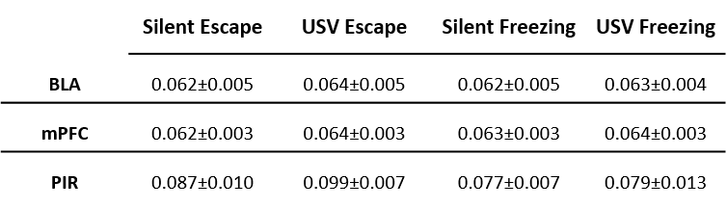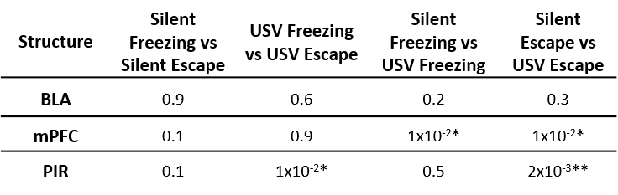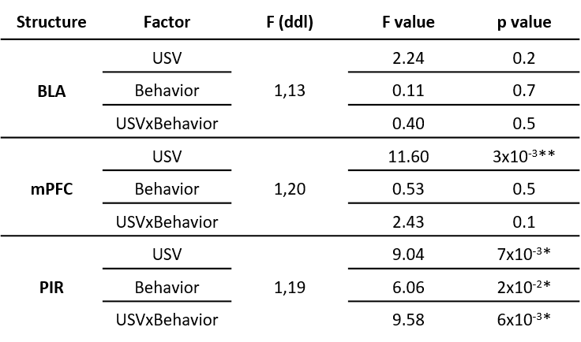

**Figure 4-1:** Beta band mean power values (+/- sem) in the three recording sites (upper table), ANOVA analysis (middle table), and p values for post-hoc comparisons (lower table).

* : p≤5x10-2, ** : p≤5x10-3, *** : p≤5x10-4.