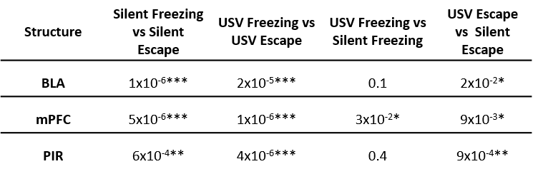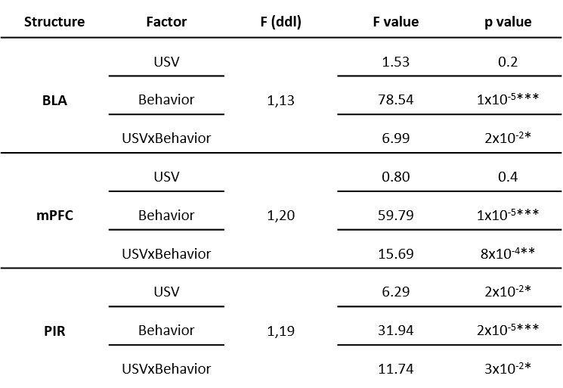

**Figure 4-2:** Gamma band mean power statistical data in the three recording sites: ANOVA analysis (upper table) and p values for post-hoc comparisons (lower table).

* : p≤5x10-2, ** : p≤5x10-3, *** : p≤5x10-4.