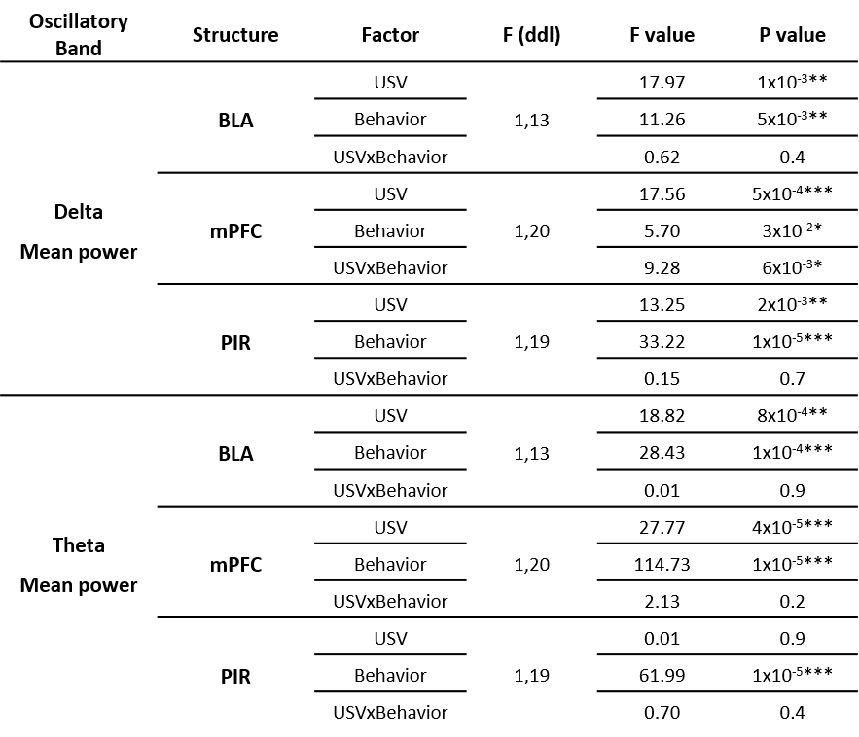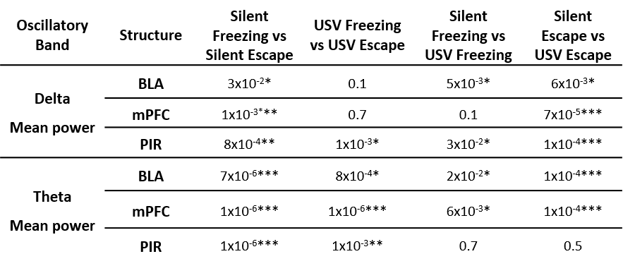

**Figure 3-1:** Delta and Theta activity mean power statistical data: ANOVA analysis (upper table) and p values for post-hoc comparisons (lower table).

* : p≤5x10-2, ** : p≤5x10-3, *** : p≤5x10-4.